Returns
The FTSE JSE All Share (ALSI) has dipped into negative territory on the year after two brutal trading days for global equities. Chart 1: ALSI YTD % Change Chart 2: ALSI Sectors % of Stocks Above 50 – DMAs Chart 3 – 6, ALSI Price; ALSI 10 – Day A/D Line; % of ALSI Stocks Above 50 – DMAs; ALSI Trailing 12 – Mth P/E (x).

Figure 1: FTSE JSE ALSI (Pts)
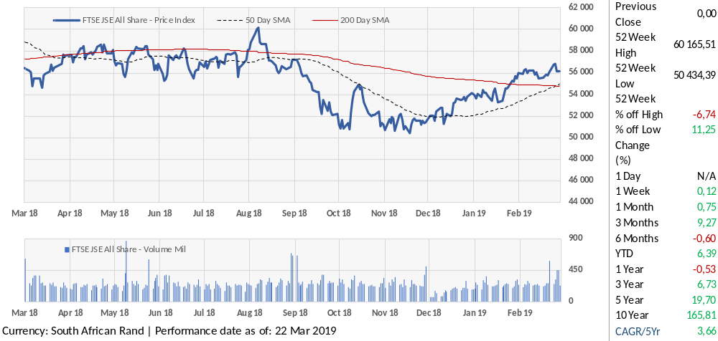
Source: Merit Stocks, Factset

The FTSE JSE All Share (ALSI) has dipped into negative territory on the year after two brutal trading days for global equities. Chart 1: ALSI YTD % Change Chart 2: ALSI Sectors % of Stocks Above 50 – DMAs Chart 3 – 6, ALSI Price; ALSI 10 – Day A/D Line; % of ALSI Stocks Above 50 – DMAs; ALSI Trailing 12 – Mth P/E (x).

Figure 2: FTSE JSE Sector Performance – Year to Date (YTD) Total Return (%)
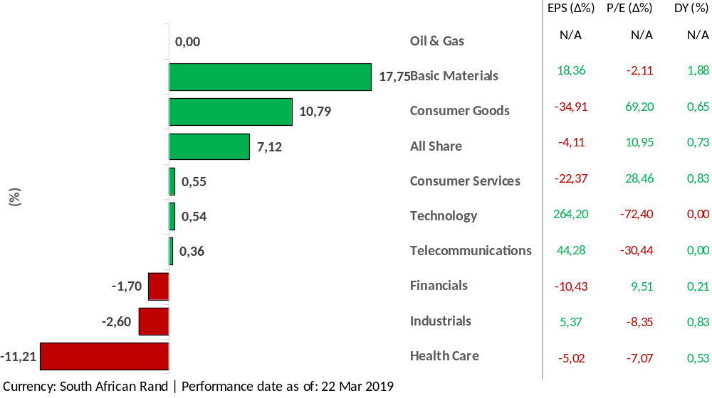
Source: Merit Stocks, Factset
The FTSE JSE All Share (ALSI) has dipped into negative territory on the year after two brutal trading days for global equities. Chart 1: ALSI YTD % Change Chart 2: ALSI Sectors % of Stocks Above 50 – DMAs Chart 3 – 6, ALSI Price; ALSI 10 – Day A/D Line; % of ALSI Stocks Above 50 – DMAs; ALSI Trailing 12 – Mth P/E (x).

Figure 3: FTSE JSE ALSI – Momentum and Relative Strength Indicator (RSI)
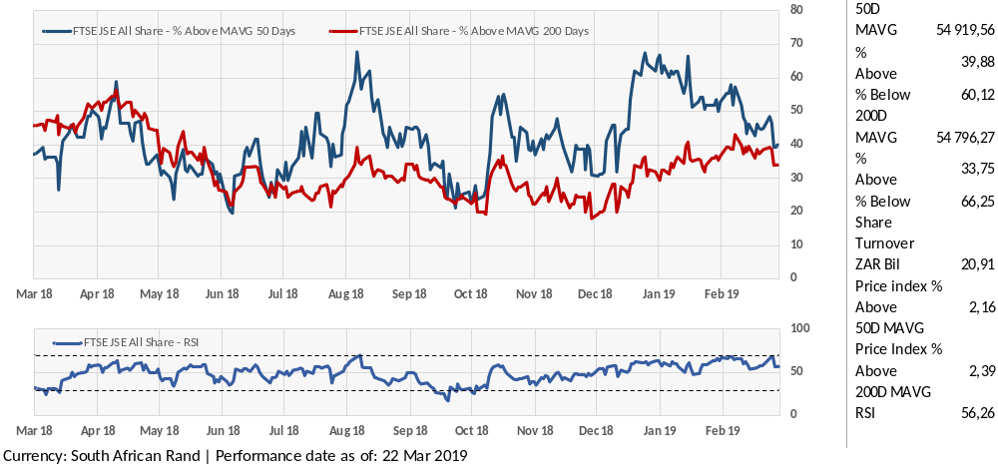
Source: Merit Stocks, Factset

The FTSE JSE All Share (ALSI) has dipped into negative territory on the year after two brutal trading days for global equities. Chart 1: ALSI YTD % Change Chart 2: ALSI Sectors % of Stocks Above 50 – DMAs Chart 3 – 6, ALSI Price; ALSI 10 – Day A/D Line; % of ALSI Stocks Above 50 – DMAs; ALSI Trailing 12 – Mth P/E (x).

Figure 4: FTSE JSE Percentage of Stocks Above 50 Day SMA (%)
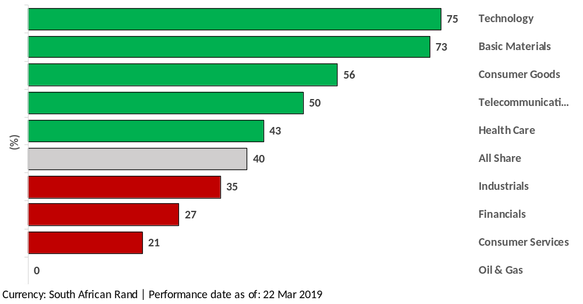
Source: Merit Stocks, Factset

Focus on Basic Materials
The FTSE JSE All Share (ALSI) has dipped into negative territory on the year after two brutal trading days for global equities. Chart 1: ALSI YTD % Change Chart 2: ALSI Sectors % of Stocks Above 50 – DMAs Chart 3 – 6, ALSI Price; ALSI 10 – Day A/D Line; % of ALSI Stocks Above 50 – DMAs; ALSI Trailing 12 – Mth P/E (x). The FTSE JSE All Share (ALSI) has dipped into negative territory on the year after two brutal trading days for global equities. Chart 1: ALSI YTD % Change Chart 2: ALSI Sectors % of Stocks Above 50 – DMAs Chart 3 – 6, ALSI Price; ALSI 10 – Day A/D Line; % of ALSI Stocks Above 50 – DMAs; ALSI Trailing 12 – Mth P/E (x).

Mth P/E (x). The FTSE JSE All Share (ALSI) has dipped into negative territory on the year after two brutal trading days for global equities. Chart 1: ALSI YTD % Change Chart 2: ALSI Sectors % of Stocks Above 50 – DMAs Chart 3 – 6, ALSI Price; ALSI 10 – Day A/D Line; % of ALSI Stocks Above 50 – DMAs; ALSI Trailing 12 – Mth P/E (x).

Figure 5: FTSE JSE Basic Materials Versus ALSI – Total Return (%)
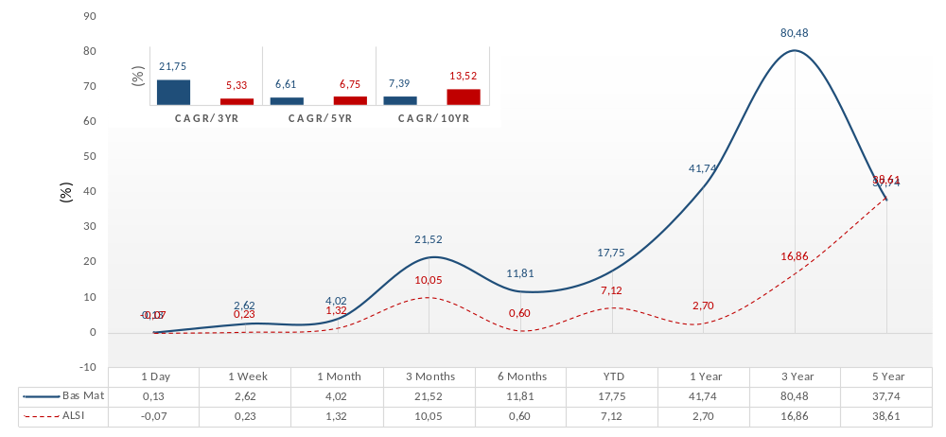
Source: Merit Stocks, Factset

The FTSE JSE All Share (ALSI) has dipped into negative territory on the year after two brutal trading days for global equities. Chart 1: ALSI YTD % Change Chart 2: ALSI Sectors % of Stocks Above 50 – DMAs Chart 3 – 6, ALSI Price; ALSI 10 – Day A/D Line; % of ALSI Stocks Above 50 – DMAs; ALSI Trailing 12 – Mth P/E (x). The FTSE JSE All Share (ALSI) has dipped into negative territory on the year after two brutal trading days for global equities. Chart 1: ALSI YTD % Change Chart 2: ALSI Sectors % of Stocks Above 50 – DMAs Chart 3 – 6, ALSI Price; ALSI 10 – Day A/D Line; % of ALSI Stocks Above 50 – DMAs; ALSI Trailing 12 – Mth P/E (x).

Mth P/E (x). The FTSE JSE All Share (ALSI) has dipped into negative territory on the year after two brutal trading days for global equities. Chart 1: ALSI YTD % Change Chart 2: ALSI Sectors % of Stocks Above 50 – DMAs Chart 3 – 6, ALSI Price; ALSI 10 – Day A/D Line; % of ALSI Stocks Above 50 – DMAs; ALSI Trailing 12 – Mth P/E (x). Mth P/E (x). The FTSE JSE All Share (ALSI) has dipped into negative territory on the year after two brutal trading days for global equities. Chart 1: ALSI YTD % Change Chart 2: ALSI Sectors % of Stocks Above 50 – DMAs Chart 3 – 6, ALSI Price; ALSI 10 – Day A/D Line; % of ALSI Stocks Above 50 – DMAs; ALSI Trailing 12 – Mth P/E (x). Chart 1: ALSI YTD % Change Chart 2: ALSI Sectors % of Stocks Above 50 – DMAs Chart 3 – 6, ALSI Price; ALSI 10 – Day A/D Line; % of ALSI.

Valuation
The FTSE JSE All Share (ALSI) has dipped into negative territory on the year after two brutal trading days for global equities. Chart 1: ALSI YTD % Change Chart 2: ALSI Sectors % of Stocks Above 50 – DMAs Chart 3 – 6, ALSI Price; ALSI 10 – Day A/D Line; % of ALSI Stocks Above 50 – DMAs; ALSI Trailing 12 – Mth P/E (x). The FTSE JSE All Share (ALSI) has dipped into negative territory on the year after two brutal trading days for global equities. Chart 1: ALSI YTD % Change Chart 2: ALSI Sectors % of Stocks Above 50 – DMAs Chart 3 – 6, ALSI Price; ALSI 10 – Day A/D Line; % of ALSI Stocks Above 50 – DMAs; ALSI Trailing 12 – Mth P/E (x).

Figure 6: FTSE JSE P/E LTM (x) Versus EPS Gr. (%) (+12M)
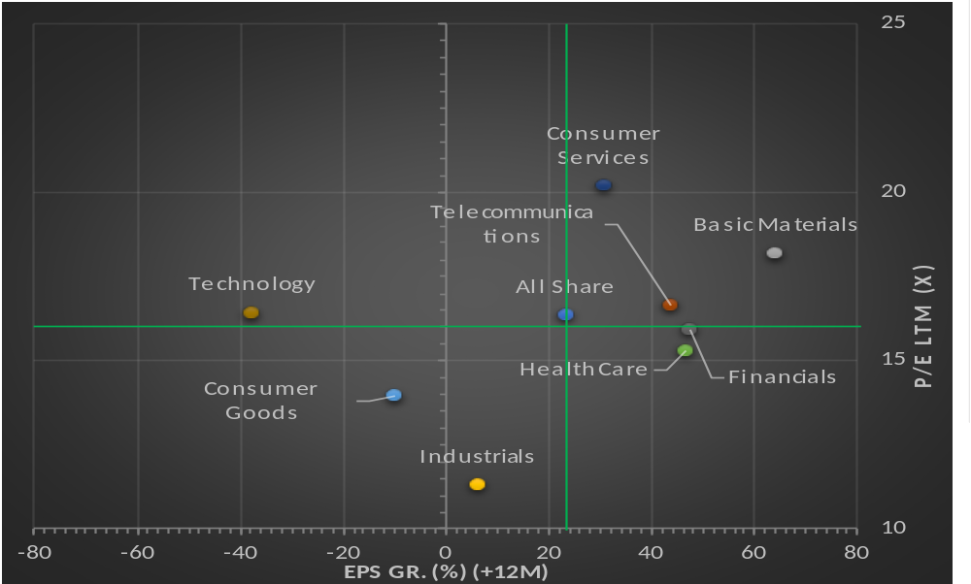
Source: Merit Stocks, Factset

Mth P/E (x). The FTSE JSE All Share (ALSI) has dipped into negative territory on the year after two brutal trading days for global equities. Chart 1: ALSI YTD % Change Chart 2: ALSI Sectors % of Stocks Above 50 – DMAs Chart 3 – 6, ALSI Price; ALSI 10 – Day A/D Line; % of ALSI Stocks Above 50 – DMAs; ALSI Trailing 12 – Mth P/E (x). Mth P/E (x). The FTSE JSE All Share (ALSI) has dipped into negative territory on the year after two brutal trading days for global equities. Chart 1: ALSI YTD % Change Chart 2: ALSI Sectors % of Stocks Above 50 – DMAs Chart 3 – 6, ALSI Price; ALSI 10 – Day A/D Line; % of ALSI Stocks Above 50 – DMAs; ALSI Trailing 12 – Mth P/E (x). Chart 1: ALSI YTD % Change Chart 2: ALSI Sectors % of Stocks Above 50 – DMAs Chart 3 – 6, ALSI Price; ALSI 10 – Day A/D Line; % of ALSI.

Mth P/E (x). The FTSE JSE All Share (ALSI) has dipped into negative territory on the year after two brutal trading days for global equities. Chart 1: ALSI YTD % Change Chart 2: ALSI Sectors % of Stocks Above 50 – DMAs Chart 3 – 6, ALSI Price; ALSI 10 – Day A/D Line; % of ALSI Stocks Above 50 – DMAs; ALSI Trailing 12 – Mth P/E (x). Mth P/E (x). The FTSE JSE All Share (ALSI) has dipped into negative territory on the year after two brutal trading days for global equities. Chart 1: ALSI YTD % Change Chart 2: ALSI Sectors % of Stocks Above 50 – DMAs Chart 3 – 6, ALSI Price; ALSI 10 – Day A/D Line; % of ALSI Stocks Above 50 – DMAs; ALSI Trailing 12 – Mth P/E (x). Chart 1: ALSI YTD % Change Chart 2: ALSI Sectors % of Stocks Above 50 – DMAs Chart 3 – 6, ALSI Price; ALSI 10 – Day A/D Line; % of ALSI. The FTSE JSE All Share (ALSI) has dipped into negative territory on the year after two brutal trading days for global equities. Chart 1: ALSI YTD % Change Chart 2: ALSI Sectors % of Stocks Above 50 – DMAs Chart 3 – 6, ALSI Price; ALSI 10 – Day A/D Line; % of ALSI Stocks Above 50 – DMAs; ALSI Trailing 12 – Mth P/E (x). The FTSE JSE All Share (ALSI) has dipped into negative territory on the year after two brutal trading days for global equities. Chart 1: ALSI YTD % Change Chart 2: ALSI Sectors % of Stocks Above 50 – DMAs Chart 3 – 6, ALSI Price; ALSI 10 – Day A/D Line; % of ALSI Stocks Above 50 – DMAs;

Figure 7: FTSE JSE PEG Ratios
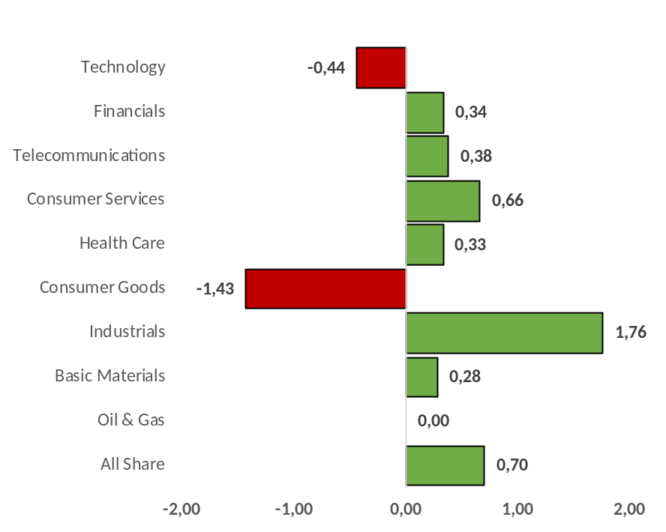
Source: Merit Stocks, Factset

ALSI Trailing 12 – Mth P/E (x).
Mth P/E (x). The FTSE JSE All Share (ALSI) has dipped into negative territory on the year after two brutal trading days for global equities. Chart 1: ALSI YTD % Change Chart 2: ALSI Sectors % of Stocks Above 50 – DMAs Chart 3 – 6, ALSI Price; ALSI 10 – Day A/D Line; % of ALSI Stocks Above 50 – DMAs; ALSI Trailing 12 – Mth P/E (x).
Sectors % of Stocks Above 50 – DMAs Chart 3 – 6, ALSI Price; ALSI 10 – Day A/D Line; % of ALSI. The FTSE JSE All Share (ALSI) has dipped into negative territory on the year after two brutal trading days for global equities. Chart 1: ALSI YTD % Change Chart 2: ALSI Sectors % of Stocks Above 50 – DMAs

Chart 3 – 6, ALSI Price; ALSI 10 – Day A/D Line; % of ALSI Stocks Above 50 – DMAs; ALSI Trailing 12 – Mth P/E (x). The FTSE JSE All Share (ALSI) has dipped into negative territory on the year after two brutal trading days for global equities. Chart 1: ALSI YTD % Change Chart 2: ALSI Sectors % of Stocks Above 50 – DMAs Chart 3 – 6, ALSI Price; ALSI 10 – Day A/D Line; % of ALSI Stocks Above 50 – DMAs;
Mth P/E (x). The FTSE JSE All Share (ALSI) has dipped into negative territory on the year after two brutal trading days for global equities. Chart 1: ALSI YTD % Change Chart 2: ALSI Sectors % of Stocks Above 50 – DMAs Chart 3 – 6, ALSI Price; ALSI 10 – Day A/D Line; % of ALSI Stocks Above 50 – DMAs;
brutal trading days for global equities. Chart 1: ALSI YTD % Change Chart 2: ALSI Sectors % of Stocks Above 50 – DMAs Chart 3 – 6, ALSI Price; ALSI 10 – Day A/D Line; % of ALSI Stocks Above 50 – DMAs;

Figure 8: Valuation Matrix
ICB |  | P/E LTM | P/E CY1 | P/E CY2 | P/E NTM | P/S | P/B | P/CF | EV/EBITDA | EV/EBIT | EV/S | DY
Industry |  | (x) | (x) | (x) | (x) | (x) | (x) | (x) | (x) | (x) | (x) | (%)
All Share |  | 15,90 | 13,27 | 12,01 | 12,99 | 1,80 | 1,90 | 10,94 | 10,25 | 14,93 | 2,07 | 2,84
Financials |  | 15,31 | 10,60 | 9,64 | 10,39 | 2,27 | 1,42 | 9,64 | 18,85 | 23,81 | 8,99 | 4,65
Consumer Services |  | 19,79 | 15,75 | 13,95 | 15,35 | 0,73 | 3,53 | 12,18 | 9,71 | 12,86 | 0,82 | 2,90
Basic Materials |  | 17,91 | 11,13 | 11,01 | 11,11 | 1,58 | 1,80 | 6,90 | 6,95 | 10,39 | 1,93 | 2,27
Consumer Goods |  | 14,04 | 15,99 | 14,33 | 15,62 | 2,40 | 1,81 | 14,00 | 12,03 | 14,94 | 2,68 | 3,55
Industrials |  | 10,89 | 10,86 | 9,15 | 10,48 | 0,73 | 1,24 | 11,75 | 8,28 | 12,05 | 0,88 | 3,01
Telecommunications |  | 17,21 | 12,39 | 10,82 | 12,04 | 1,33 | 2,06 | 5,99 | 4,96 | 8,69 | 1,75 | 6,41
Health Care |  | 14,93 | 10,36 | 9,29 | 10,12 | 1,24 | 1,31 | 9,61 | 9,26 | 11,68 | 2,01 | 3,34
Technology |  | 15,47 | 25,92 | 19,24 | 24,44 | 9,06 | 3,67 | 393,36 | 216,34 | 2 673,88 | 8,32 | 0,21
Oil & Gas |  | N/A | N/A | N/A | N/A | N/A | N/A | N/A | N/A | N/A | N/A | N/A

Source: Merit Stocks, Factset Market Aggregates

Key:
All multiples are estimated using current share prices - P.
EV - Enterprise Value is estimated using Market Value of Equity plus Net Debt i.e. Debt less Cash and Cash Equivalents. EBITDA - Earnings before Interest, Taxation, Depreciation and Amortisation. EBIT - Earnings before Interest and Taxation. DY - Dividend Yield.
P/E LTM (x) - Price to Earnings multiple is estimated using trailing twelve months earnings ; P/E CY1 (x) - Price to Earnings multiple is estimated using consensus earnings forecast for the current calendar year; P/E CY2 (x) - Price to Earnings multiple is estimated using consensus earnings forecast for the next calendar year; P/E NTM (x) - Price to Earnings multiple is estimated using consensus earnings forecast for the next twelve months; P/S (x) - Price to Sales multiple is estimated using trailing twelve months of sales; P/B (x) - Price to Book multiple is estimated using the latest historical book (accounting) values of equity; P/CF (x) - Price to Cash Flow multiple is estimated using the latest historical cash flow from operations; EV/EBITDA multiple is estimated using current market values of equity and historical Net Debt and EBITDA numbers; EV/EBIT multiple is estimated using current market values of equity and historical Net Debt and EBIT numbers; EV/S multiple is estimated using current market values of equity and historical Net Debt and Sales numbers. DY is estimated using current share prices and trailing twelve months dividends.

Figure 9: FTSE JSE All Share – Trading Areas | Figure 10: FTSE JSE Oil & Gas – Trading Areas
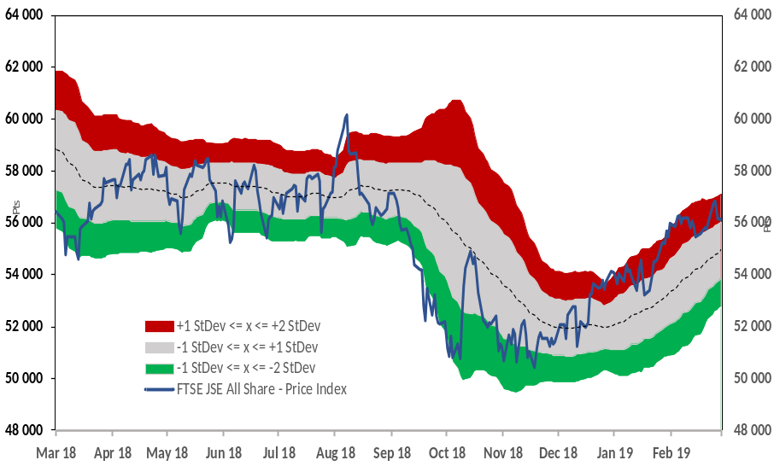 | 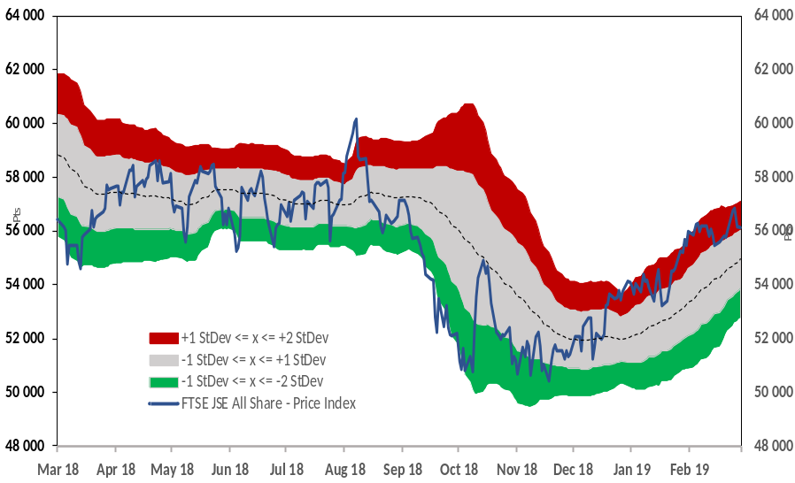
Source: Merit Stocks, Factset | Source: Merit Stocks, Factset
Figure 11: FTSE JSE Basic Materials – Trading Areas | Figure 12: FTSE JSE Industrials – Trading Areas
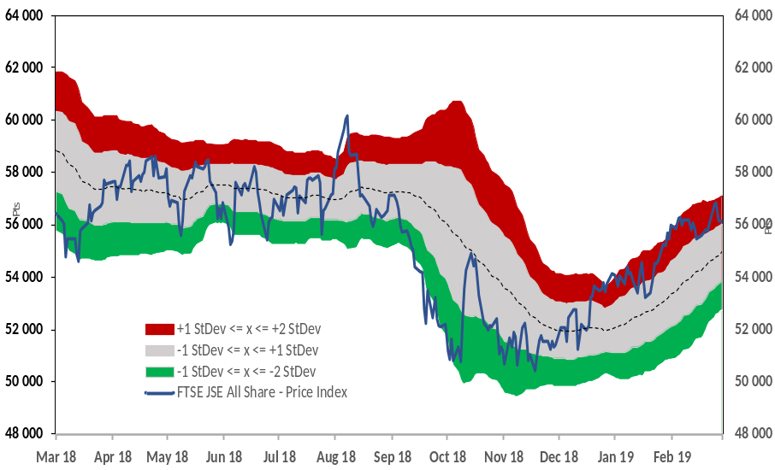 | 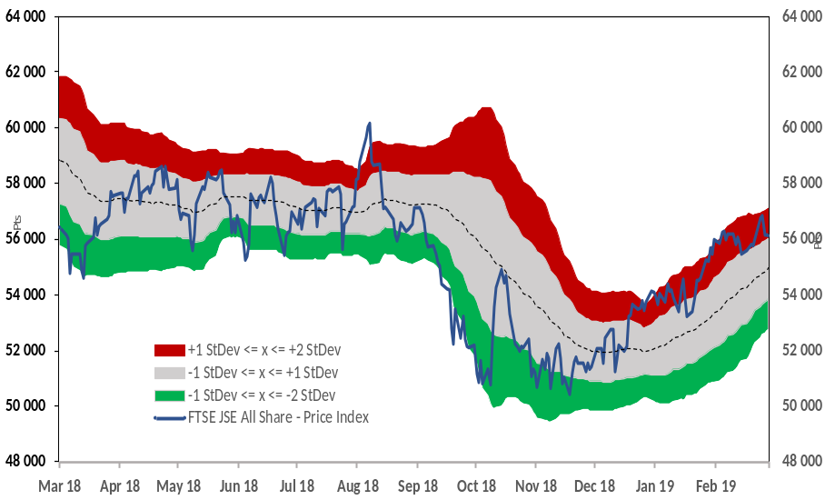
Source: Merit Stocks, Factset | Source: Merit Stocks, Factset

Figure 13: FTSE JSE Consumer Goods – Trading Areas | Figure 14: FTSE JSE Health Care – Trading Areas
Source: Merit Stocks, Factset | Source: Merit Stocks, Factset
Figure 15: FTSE JSE Consumer Services – Trading Areas | Figure 16: FTSE JSE Telecommunications – Trading Areas
Source: Merit Stocks, Factset | Source: Merit Stocks, Factset

Figure 17: FTSE JSE Financials – Trading Areas | Figure 18: FTSE JSE Technology – Trading Areas
Source: Merit Stocks, Factset | Source: Merit Stocks, Factset

Figure 19: FTSE JSE All Share – Short Term Valuation | Figure 20: FTSE JSE Oil & Gas – Short Term Valuation
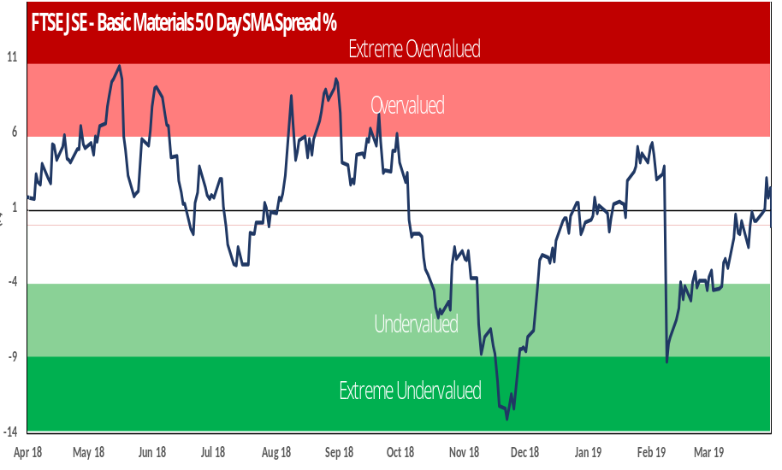
Source: Merit Stocks, Factset | Source: Merit Stocks, Factset
Figure 21: FTSE JSE Basic Materials – Short Term Valuation | Figure 22: FTSE JSE Industrials – Short Term Valuation
Source: Merit Stocks, Factset | Source: Merit Stocks, Factset

Figure 23: FTSE JSE Consumer Goods – Short Term Valuation | Figure 24: FTSE JSE Health Care – Short Term Valuation
Source: Merit Stocks, Factset | Source: Merit Stocks, Factset
Figure 25: FTSE JSE Consumer Services – Short Term Valuation | Figure 26: FTSE JSE Telecommunications – Short Term Valuation
Source: Merit Stocks, Factset | Source: Merit Stocks, Factset

Figure 27: FTSE JSE Financials – Short Term Valuation | Figure 28: FTSE JSE Technology – Short Term Valuation
Source: Merit Stocks, Factset | Source: Merit Stocks, Factset

Figure 29: FTSE JSE All Share – P/E LTM (x) | Figure 30: FTSE JSE Oil & Gas – P/E LTM (x)
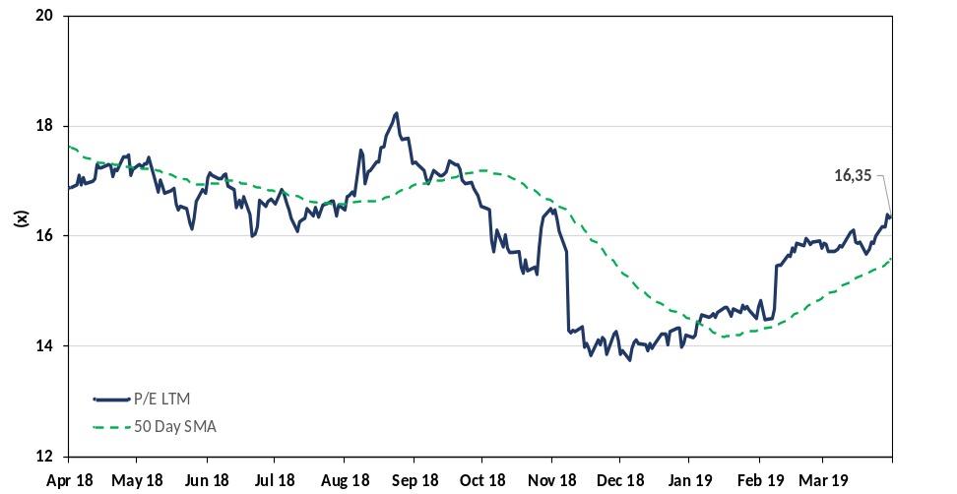 | 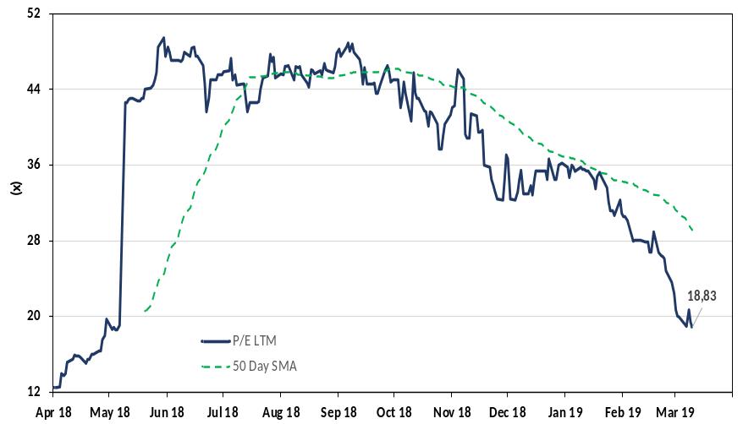
Source: Merit Stocks, Factset | Source: Merit Stocks, Factset
Figure 31: FTSE JSE Basic Materials – P/E LTM (x) | Figure 32: FTSE JSE Industrials – P/E LTM (x)
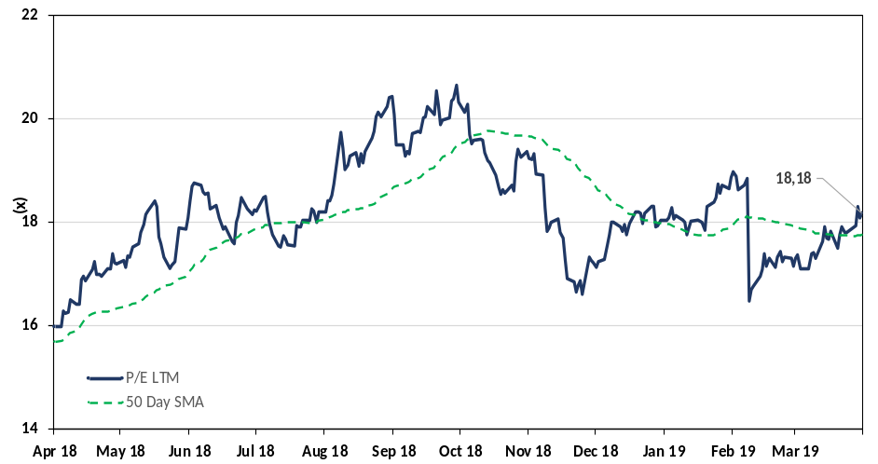 | 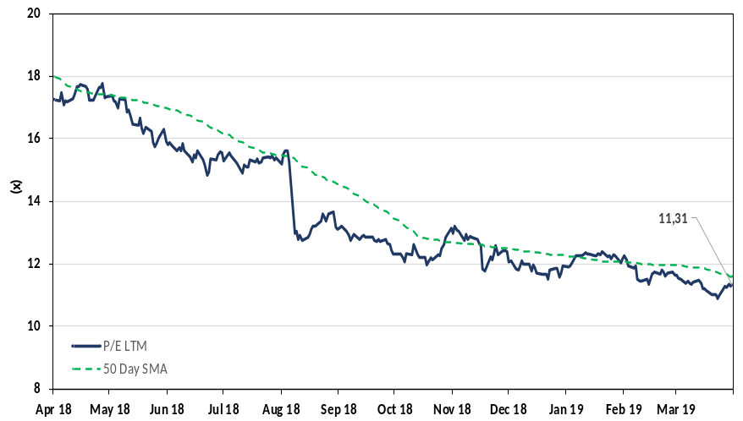
Source: Merit Stocks, Factset | Source: Merit Stocks, Factset

Figure 33: FTSE JSE Consumer Goods – P/E LTM (x) | Figure 34: FTSE JSE Health Care – P/E LTM (x)
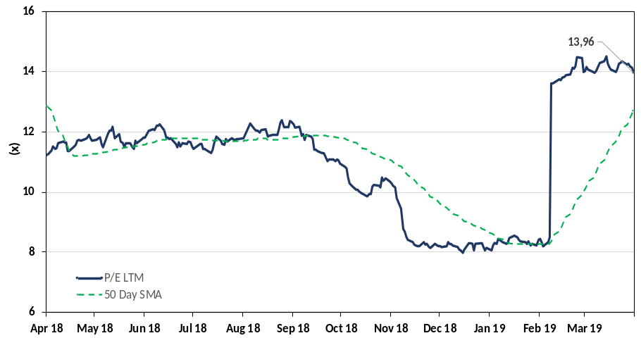 | 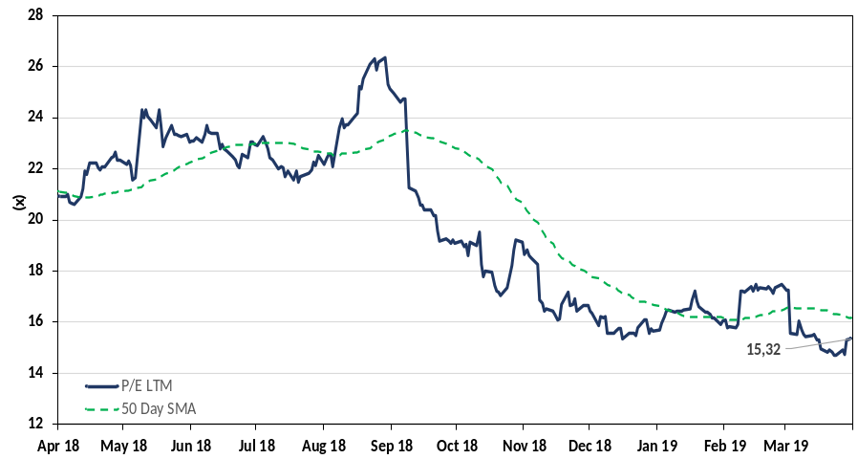
Source: Merit Stocks, Factset | Source: Merit Stocks, Factset
Figure 35: FTSE JSE Consumer Services – P/E LTM (x) | Figure 36: FTSE JSE Telecommunications – P/E LTM (x)
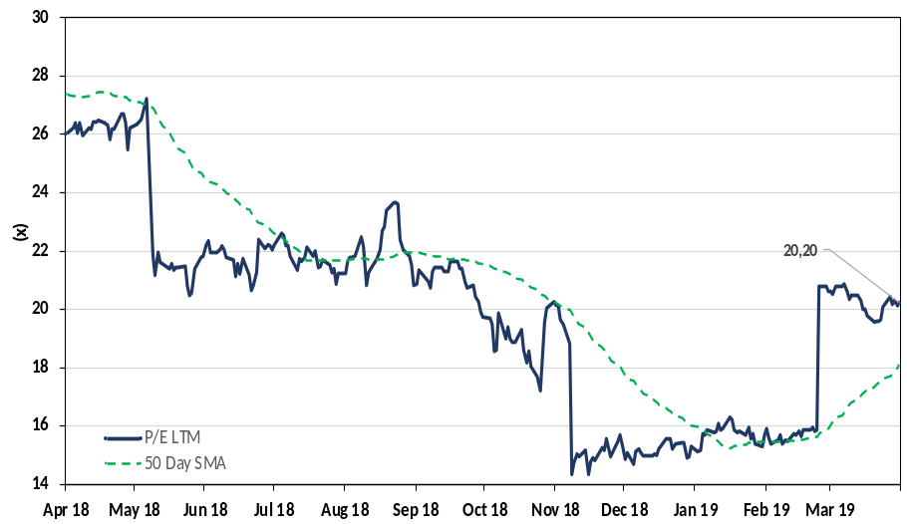 | 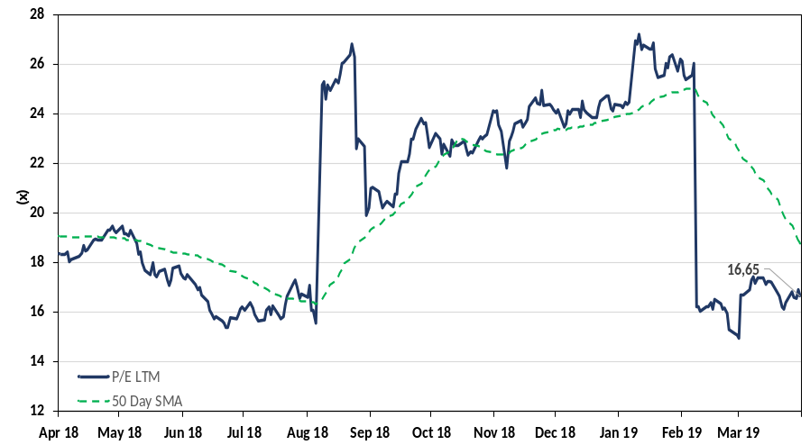
Source: Merit Stocks, Factset | Source: Merit Stocks, Factset

Figure 37: FTSE JSE Financials – P/E LTM (x) | Figure 38: FTSE JSE Technology – P/E LTM (x)
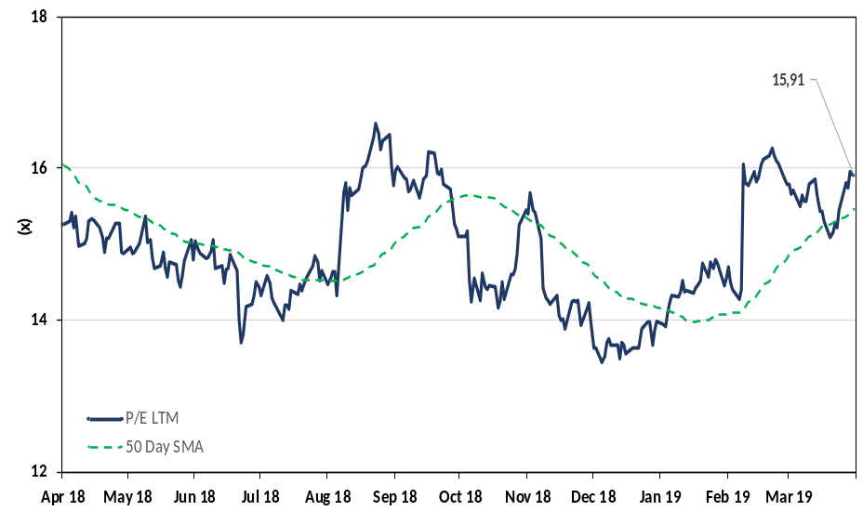 | 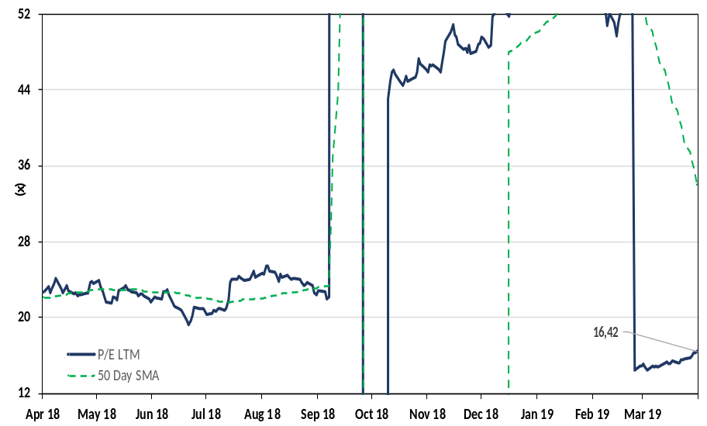
Source: Merit Stocks, Factset | Source: Merit Stocks, Factset

